复习 html

<img alt=”” src=”” width=”” height=””>

<a href=”” >kuaile xiao ju</a>

<ol>

<li>xxxx</li>

</ol>

<ul>

<li>

</ul>

<dl>

<dt></dt>

<dd></dd>

</dl>

<table>

<caption></caption>

<tr>

<th><th>

<td>

</td>

</tr>

</table>

<form action=””>

</form>

<Label>ruozhi</Label>

<input type=”text” name=”123” id=:123:>

<label> password</label>

<input type=”password” name=”123”>

<label>What type of coffee do you like

<select name=”coffee”>

<option value=”123”> xxxx</option>

</select>

</label>

<form action=””>

<label>woshiyigechaojichusheng

<input type=”radio” name=”123” value=”1”> 1

</label>

<label>

<input type=”radio” name=”123” value=2>

</label>

</form>

Document.woshiyigechaojichusheng.123.value

总而言之,type类型radio或者checkbox, name要都一样，确定是一个东西，value就是实际值，Input和label结尾之间的东西就是显示的东西

<form action=””>

<input type=”submit” value=”Submit”>

所有的都应该加form

Submit button reset  
.

Css

<x style=”asdf;qwe;zxcv;qwe;asdf;zxcvb;”>

<style type=”text/css”>

</style>

<link rel=”stylesheet” type=”text/css” href=”abc.xxx” />

.xx{}

p.XX{}

CLASS=””

P#XX{}

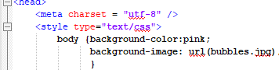

<input type="number" name="number">

内边距，如果这个数字大，

黄色就会变成一大块

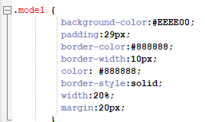

Margin就是离周边距离，border-width就是灰色

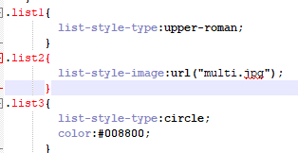

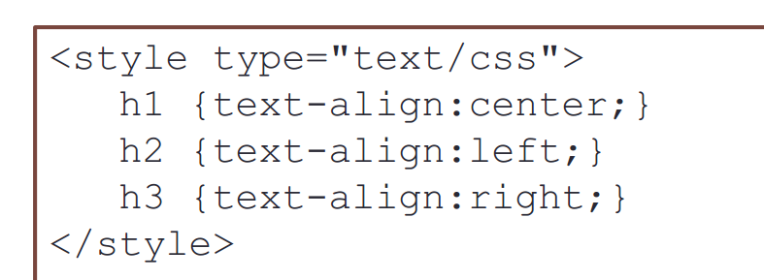



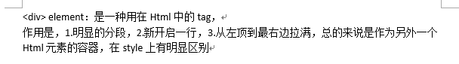

<script type=”text/javaScript” src=””>

</script>

<script>

<!—

//-->

</script>

+-x/

-x/尽量转换

Alert()

Document.write

Prompt(“”,21);

Confirm(“”);

Var a=[“”.];

1. split(“”);
2. splice(2,3,”asdfef”);

for(var in a){

var retard=new Object();

retard.iq=”30”;

retard=age=0;

var whatwewant=retard.iq;

delete retard.iq;

function dog(newType,newGender)

{

This.type=

}

\d \w

\d[asdfqwe]{2,}c

J检查是不是空的方法

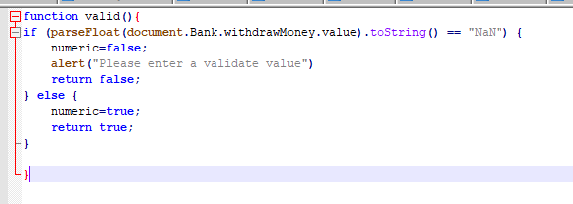



注意这个，如果没写这个，那么就会直接跳过

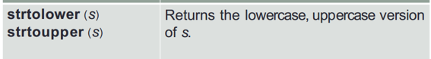



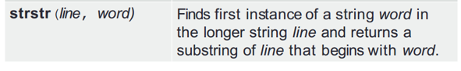

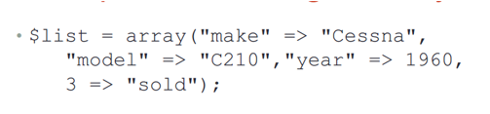



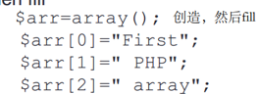

<?php

<include>

?>

<form action=”” method=”GET”>

$_GET[“name”]